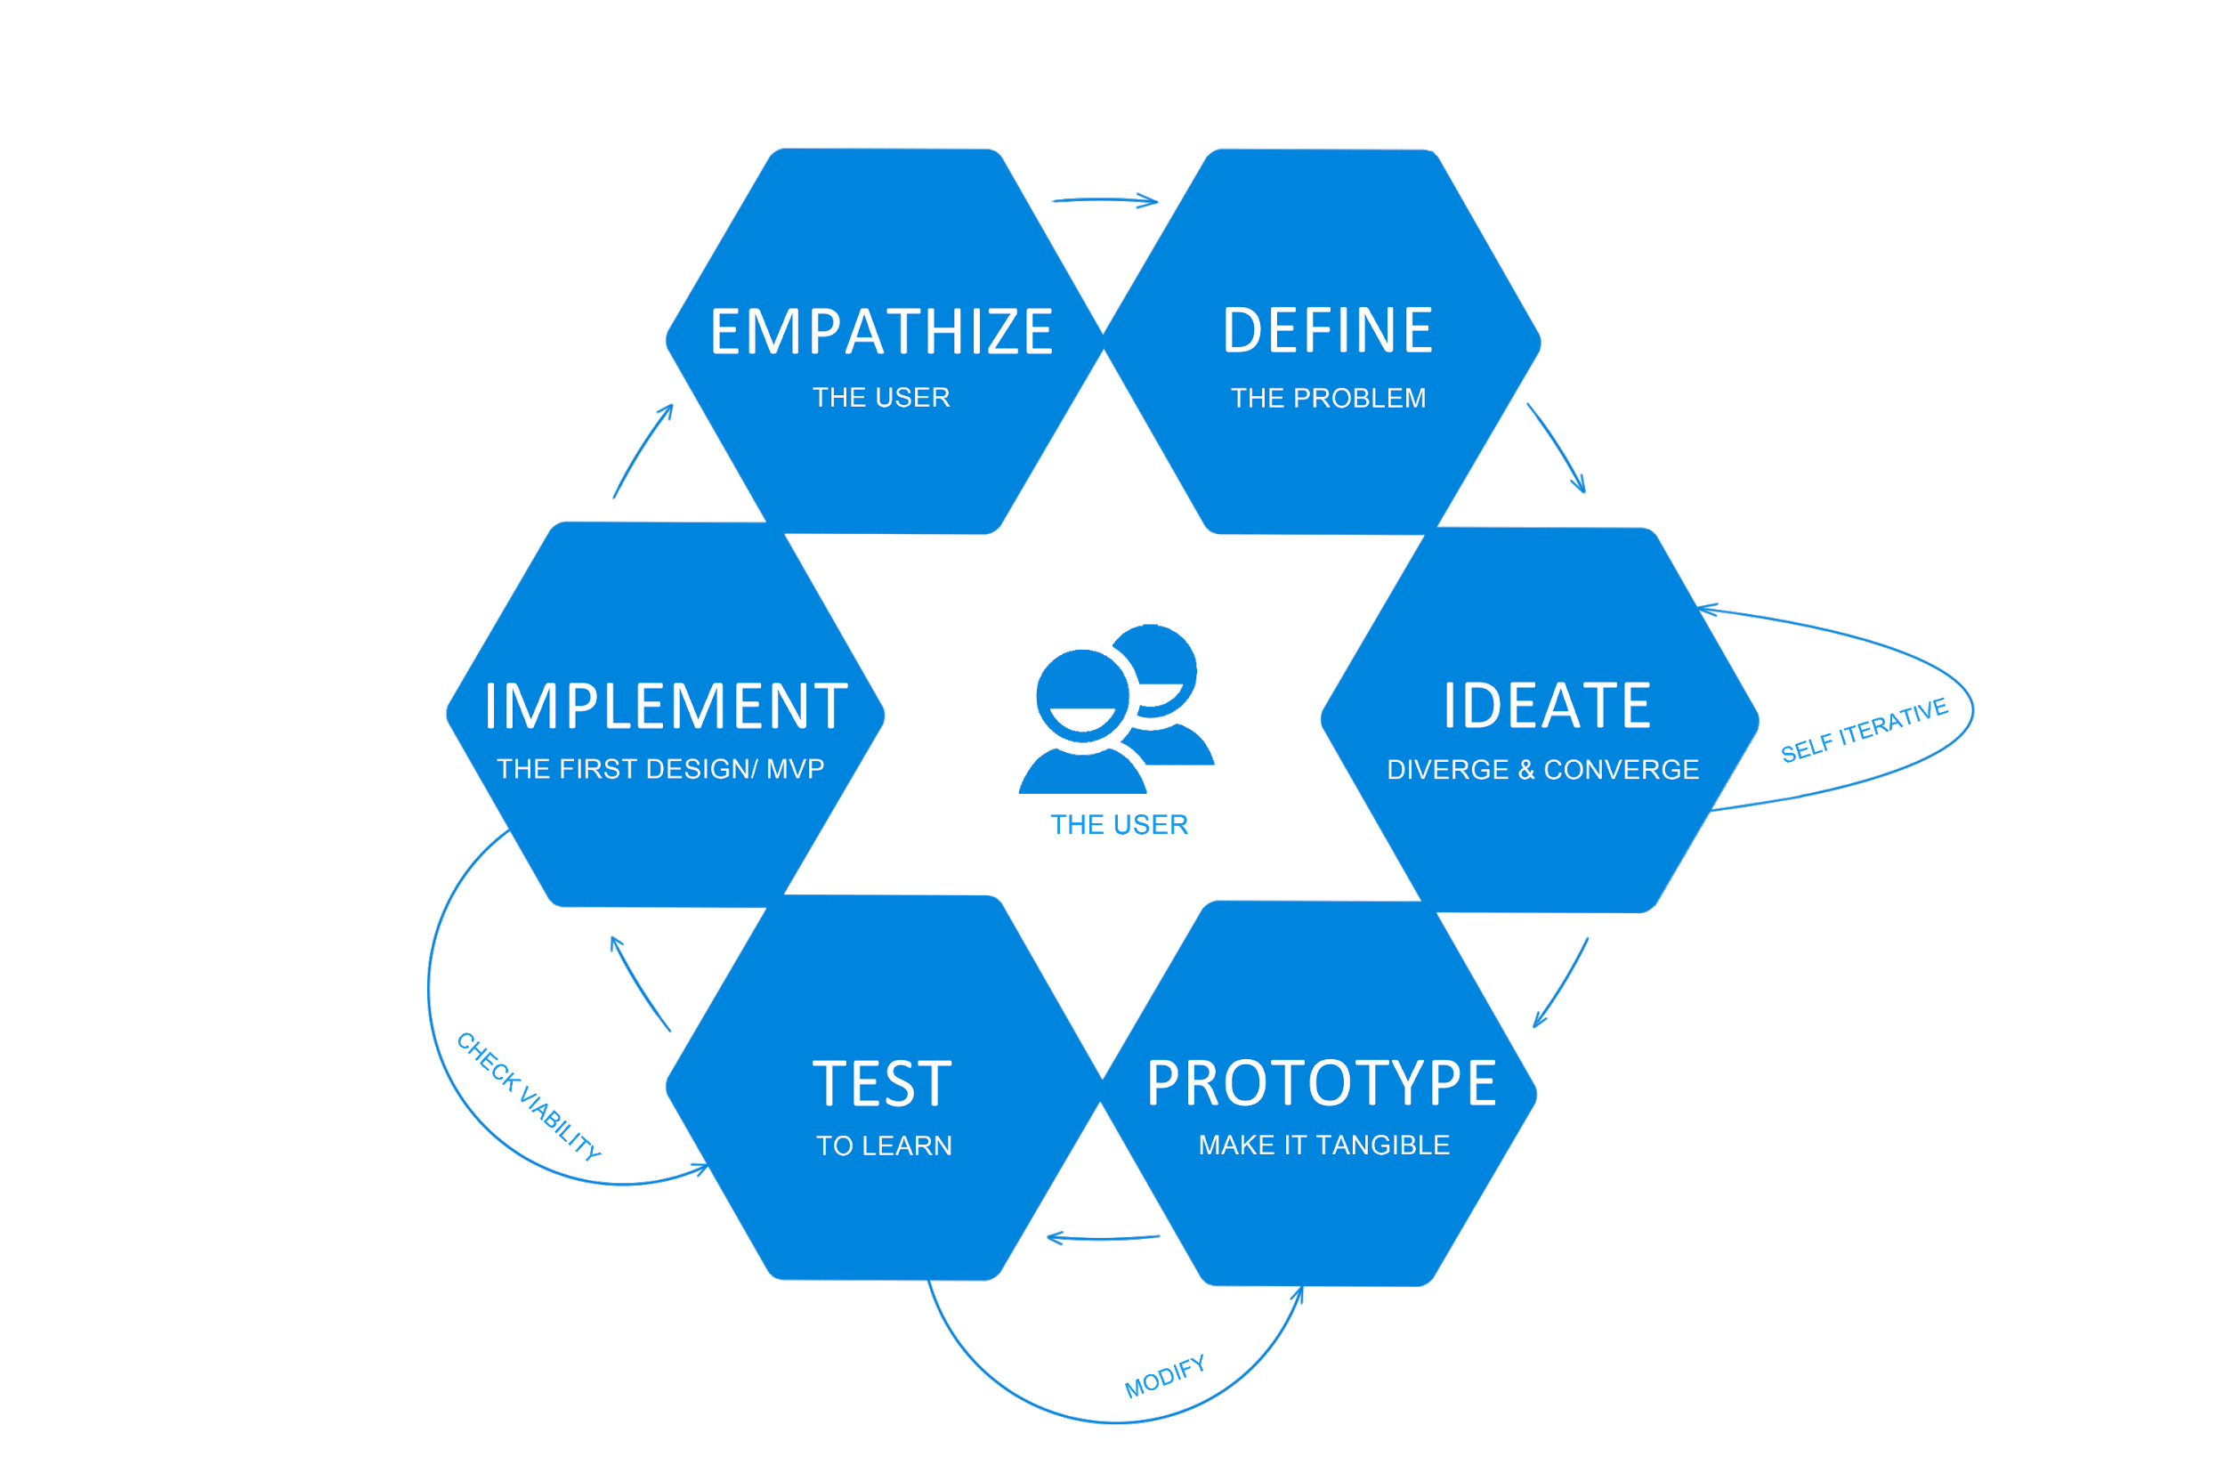

## **Identifying User Requirements**

Prior to making any prototype, we had to find out what the user requirements are. In order to find this out, we drafted a quantitative survey for our fellow CS2003 students. We choose a quantitative based survey as we wanted to calculate the average of the user’s feedback and identity if that area needs to be improved or not.

Note: The surveying users used the local library as point of reference (Brunel Library in this case).

Ten questions were asked to 10 users in the survey. The above chart shows the user's responses to some of the questions. We calculated the average and decided if its equal or below 5 we will work on those areas and find ways to improve them to create our first prototype. For example, we can assume locating a book in the library is an issue as the average came out to be '7.5'. 

**Star Methodology**

We used star methodology as our project as an evaluation centric, where we plan to put our prototype in cycle and keep repeating the cycle until we get finalised prototype with minimal or no errors. Following are some steps that will be carried out under star methodology; Group meeting, prototype surveying, evaluating feedback and improving prototype based on feedback. This image represents the process of evaluating the prototypes “Star Methodology”.

## **Generating and Conducting Heuristic Evaluation:**

**Establishing Heuristics:**

The first step was to develop a set of testing category's (heuristics) for us to compare iterations of our app in and be able to collect user opinions and data. The full list of our categories are in the heuristic table below this section. Some of our chosen heuristics are: **Aesthetic and Minimalist Design, Flexibility and Efficiency of use** and **Help and Documentation.** These choices were made from our market research and our own observation of other similar apps such as amazon, netflix, and other book apps.

**Selecting Evaluators:**

Selecting our evaluators was simple as we were only allowed to collect data from our fellow course members but we still tried to get an even sample of ages and genders to create as unbiased a collection of data as possible. Our course members are also familiar with the evaluation process and will therefore be able to ably evaluate the set of heuristics we have designed. Our evaluators are familiar with the type of system our app is built for, we have selected a group of individuals that have experience using libraries and library apps to enable a smooth evaluation process.

**Briefing Evaluators:**

We have created a standardised brief for our evaluators to make sure they are all told the same things to do and to test. This will ensure none of our results are biased. We will in this case give them a set of features based on a our heuristics list to evaluate and provide feedback on. This will create a narrower focus for us to work on that if we let them have free rain to test all functions of the app. This will enable us to focus on certain aspects of each prototype for each iteration.

**Evaluation Phase:**

Now that we have setup what we want to be tested and briefed our evaluators we can test the prototype. This first evaluation will allow the users to gain familiarity with the prototype and discover the features we want them to evaluate as well as evaluate the prototype in general. In this stage we let the evaluator familiarise themselves with the app for 30 minutes before we pointed them in the direction of the specific list of heuristics we wanted evaluated.

**Collecting & Filtering Data:**

The next phase will be to get the evaluators to record their data (In our provided format of a questionnaire). We have chosen to do this rather than observing the users to get a more accurate assessment of the evaluators opinion. Next we have conducted the initial filtering of the data we have collected from our fellow course students. This required us to average all of the results from our survey to produce a mean average and remove any outliers or non answers. We must make sure that a question has been answered before we include it in the average. This is an important step to ensuring the quality of the feedback we are collecting and its accuracy.

**Debriefing & Finalising**

This stage will be used to allow the evaluators to discuss their opinions and if they want to, modify their answers to the questionnaire. This will allow for a more rounded opinion and some group feedback. All of this data that has been collected will then be used to improve the design and develop a new prototype where we will do the same set of testing again, but with the same set of heuristics. We have currently repeated this 2 times and have made significant progress in the development of our prototypes according to the feedback we have gathered.

GUYS SOMEONE DO THE WRITE UP FOR THIS:

Include how did you filter the feedback you got from user(formula of some short)(Call me if you want me to explain) what steps were taken. Use bellow text as reference, its copied from internet so do not leave as it is.

* **Establish an appropriate list of heuristics.** Use Nielsen and Molich's 10 heuristics and Ben Shneiderman’s 8 golden rules as inspiration and stepping stone. Make sure to combine them with other relevant design guidelines and market research.
* **Select your evaluators.**Make sure to carefully choose your evaluators. Your evaluators should not be your end users. They should typically be usability experts and preferably with domain expertise in the industry type that your product is in. For example, an evaluator investigating a Point-of-Sale system for the restaurant industry should have at least a general understanding of restaurant operations.
* **Brief your evaluators** so they know exactly what they are meant to do and cover during their evaluation. The briefing session should be standardized to ensure the evaluators receive the same instructions; otherwise you may bias their evaluation. Within this brief, you may wish to ask the evaluators to focus on a selection of tasks, but sometimes they may state which tasks they will cover on the basis of their experience and expertise.
* **First evaluation phase.**The first evaluation generally takes around two hours, depending on the nature and complexity of your product. The evaluators will use the product freely to gain a feel for the methods of interaction and the scope. They will then identify specific elements that they want to evaluate.
* **Second evaluation phase.**In the second evaluation phase, the evaluators will carry out another run-through, whilst applying the chosen heuristics to the elements identified during the first phase. The evaluators would focus on individual elements and look at how well they fit in the overall design.
* **Record problems.**The evaluators must either record problems themselves or you should record them as they carry out their various tasks to track any problems they encounter. Be sure to ask the evaluators to be as detailed and specific as possible when recording problems.
* **Debriefing session.** The debriefing session involves collaboration between the different evaluators to collate their findings and establish a complete list of problems. They should then be encouraged to suggest potential solutions for these problems on the basis of the heuristics.

Based on user input, we were able to identify the following error and rectify them in the next version of prototype. This was the latest testing we have done.

|  |  |  |  |
| --- | --- | --- | --- |
| Nielsen and Moloch’s 10 User Interface Design Heuristics-Evaluation | | | |
|  | Version 1 | | Version 2 |
| Visibility of System Status | The System doesn’t indicate the status of the current page. Some of the pages are missing titles. Buttons don’t highest when you are on that page. Book button on the home page is very vague and doesn’t indicate what it represents. | | Recommended Changes were implemented, and no further recommendation were made |
| User Control and Freedom | The system should provide the user to cancel any step taken. Sign up page doesn’t have a cancel button. Hidden Logout Button, user found hard to logout of the app as button was provided within the “More” | | Recommended Changes were implemented, and no further recommendation were made |
| Match between the system and the real world. | Location of the Search Bar and Home page was pointed out as it was not in a traditional location(Top right-hand side). Use symbols where appropriate: for example, search bar. It's commonly used in the majority of websites. | | Recommended Changes were implemented, and no further recommendation were made |
| Consistency and Standards | Different Button style is used within a system. The System breaks external consistency as no help feature is provided within the new system. Book button on the home page is very vague and doesn’t indicate what it represents. | | Recommended Changes were implemented, and no further recommendation were made |
| Error Prevention | The System automatically renews the books that users have borrowed up to 4 times. This is a potential error , as users might forget to return the book as its auto-renewing and will end up with overdue fee charges. | | Recommended Changes were implemented, and no further recommendation were made |
| Flexibility and Efficiency of use, | Only one search option is provided. If the system provides a different category to search by, it will be easier for the user to quickly find the books they are looking for. | | Recommended Changes were implemented, and no further recommendation were made |
| Recognition vs recall in the user interface. | Menu bar location was pointed out again, along with the search bar. | | Recommended Changes were implemented, and no further recommendation were made |
| Help Users Recognize and recover from error. | When entering invalid input, the system informs the user of the error. For example: accidentally press on the logout button. It straight away logs user out. Pop up window could be added to resolve this issue. | | Recommended Changes were implemented, and no further recommendation were made |
| Aesthetic and Minimalist Design | “Welcome Feature” on homepage servers it purposes to some degree, however, takes the majority of the space. This unit of information competes with more relevant unit of information such as my list, recommended books, etc. | | Recommended Changes were implemented, and no further recommendation were made |
| Help and Documentation | Poor: Standard text is provided indicating the floor and shelf number to help the user locate books. Some people find it very hard to locate the book using this method. | | Recommended Changes were implemented, and no further recommendation were made |